**Automated Training Scripts Manual**

**Step 1 : Open the input file**

* Open the environment.txt file

**Step 2 : Write down the processes**

* Don’t change the first line of the txt file, add your process on the second line of the txt file
* Should have 3 item:
  + [conda environment name], [path to project folder], [Python script to be executed]
* Each item should be separated by a comma
* Should not contain spaces
* One line for each process
* Below Figure shows two processes:

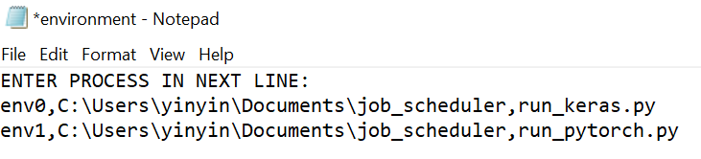

**Step 3: Set arguments in Python script**

* Add argument parser in the training script

import argparse

parser = argparse.ArgumentParser(description="Assign GPU")

parser.add_argument('-gpu',type=int)

args = parser.parse_args()

* Replace “cuda:0” or “cuda:1” with **“cuda:”+ str(args.gpu)**



* Note: When running scripts individually without the scheduler, type the following in command prompt :

**python [script_name] -gpu [gpu_number]**

**Step 4: Calling the program**

* Open main.py and change the name of the text file to the name given in Step 1.
* Open Anaconda Prompt, change the directory to the folder that contains the job scheduler script and run ‘**python main.py**’

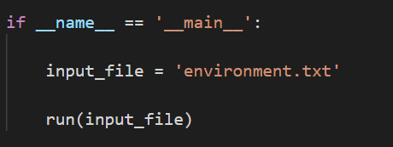

**Step 5: Confirm if process started**

* If the process has started, it should print out “[PROCESS NAME] has started” in the command prompt.



* The process in the input text file would be moved to another text file called **done.txt**.
* Any processes that has not been moved to done.txt can still be modified, added, or deleted

**Step 6: Adding process afterwards**

* Just add another line to the txt file if you want to add more processes in
* No need to run main.py again
* The program will automatically get the new process and execute it